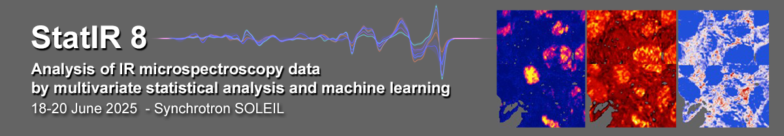

STAT-IR 8

ANALYSIS OF IR MICROSPECTROSCOPY DATA BY MULTIVARIATE STATISTICAL ANALYSIS AND MACHINE LEARNING

June 18-20, 2025

Preliminary Progamm

 |  | Wednesday, June 18 | Thursday, June 19  Supervised learning | Friday, June 20  Unsupervised learning
Session 1 | 9:00 | Getting started with Quasar (installation, basic Orange and Quasar functionality)  Speaker: C Sandt, M Toplak | Introduction to supervised and unsupervised learning  Speaker: C Sandt | Quantification  Speaker: C Sandt
Break | 10:30
Session 2 | 10:45 | Spectral Preprocessing  Visualization – mapping and imaging, univariate analysis  Speaker: C. Sandt | Supervised analysis.  Classification of spectra and hyperspectral datasets using various methods  Speaker: F Borondics | Unsupervised analysis. Clustering of spectra and hyperspectral datasets using various methods  Speaker: M Toplak
Lunch break | 12:00 13:30
Session 3 | 13:30 | Statistical data exploration  PCA, PCA visualization  PCA imaging  Speaker: C Sandt | Model inspection and cross-validation  Prediction  Common errors  Speaker: M Toplak | Image Analysis  Speaker: ??
Break | 15:30
Session 4 | 16:00 | Hands-on work with participants' data | Hands-on work with participants' data
 | 17:30

