Study Of Biomimetic Membranes Composed of Glycosylated Lipids
Ramanujam Ramanujam¹, Niki Baccile¹
¹Sorbonne Université, Centre National de la Recherche Scientifique, Laboratoire de Chimie de la Matière Condensée de Paris, LCMCP, F-75005 Paris, France

Introduction: Bio-based surfactants, derived from biomass via fermentation of glucose and vegetable oils^{1, 2}, have gained popularity due to their eco-friendly advantage over petroleum-derived surfactants, rely on the pollutive chemical processes. Microbial glycolipids (MGs) are the bio-based surfactants, and their amphiphilic nature allows them to interact with lipid bilayer membranes-key structure in all living organisms³ -while also exhibiting antibacterial, anticancer, and antiviral properties^{4, 5}. Modification to lipid membranes can significantly impact cell function, highlighting the potential of MGs in diverse application as shown in Figure 1. The self-assembly of microbial (MGs) into bilayers and their impact on biological membranes remains underexplored. Some key biophysical properties are not well understood. This study focused on exploring the biophysical properties of membrane-forming MGs and their interaction with phospholipid-based biomimetic membranes.
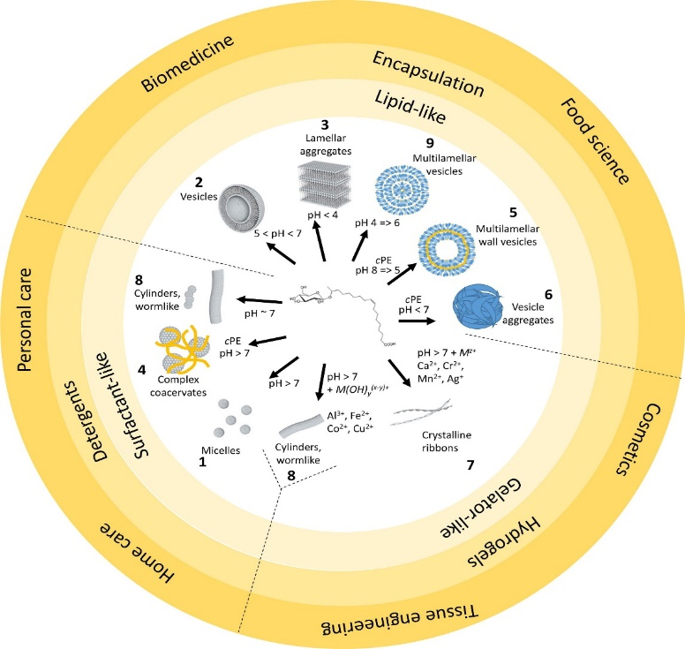
Figure 1: Phase behaviour of G-C18:1 (C<5 wt% in water) with pH and salt addition

Materials and method: Biosurfactants known to form membrane-like structures such as Acetylated G-C18:1, Acetylated Lactonic SL-C18:1, mono-rhamnolipid, trehalolipids were prepared.
Lamellar structures were prepared using Milli-Q water (18.2 MΩ). The pH is adjusted using NaOH and HCl solution (0.5M, 1M, and 5M). Fibrillation was induced with calcium chloride (CaCl₂) as a source of Ca²⁺ ions. The glycolipids studied included Glucolipids (G-C18:1, G-C18:0) and Sophorolipids (SL-C18:1, SL-C 18:0). Phospholipids vesicles, including DOPC (1,2-Dioleoyl-sn-glycero-3-phosphocholine) and DPPC (1,2 Dipalmitoylphosphatidylcholine), were synthesized in uni-lamellar vesicles (ULVs) and multi-lamellar vesicles (MLVs) forms to study the amphiphilic interactions.
Results: Biophysical properties of membrane-forming biosurfactants were analyzed using small-angle X-ray scattering (SAXS), small-angle neutron scattering (SANS), neutron spin-echo (NSE), differential scanning calorimetry (DSC), and Langmuir-Blodgett Trough, revealing bilayer thickness, bending rigidity, melting temperature, and area/molecule. Similar techniques are aimed to use further to elaborate MGs and PLs interaction.
Discussion and Conclusion: The results align with the project objectives. Further refinement of SAXS and SANS data is ongoing. Confocal microscopy is needed to confirm Giant uni-lamellar Vesicle (GUV) formation and glycolipid effects, with GUV protocols requiring optimization through several trails.
References:

- R. Marchant, Ibrahim M. Banat; Microbial bio surfactants: Challenges and opportunities for future exploitation; DOI: 10.1016/j.tibtech.2012.07.003; 2012.
- (2) I.M. Banat et al. Microbial bio surfactant production, application and future potential: DOI: 10.1007/s00253-010-2589-0, 2010.
- Francisco J. Aranda et al. Recent advances on the interaction of glycolipid and lipopeptide bio surfactants with model and biological membranes; DOI: https://doi.org/10.1016/j.cocis.2023.101748, 2023.
- Shu Q et al. Contribution of glycolipids bio surfactants and glycolipid-modified materials to antimicrobial strategy: a review; DOI: 10.3390/pharmaceutics13020227, 2021.
- Semkova S, et al. Rhamnolipids bio surfactants-possible natural anti-cancer and autophagy inhibitor; DOI: https://doi.org:10.3390:separations8070092, 2021-->For more information, please visit my portfolio: ramanujam1.com/

