Ultrashort and tunable UV source for attosecond transient absorption spectroscopy in liquid sample
N Lericheux¹, H Taleb¹, P Souchu¹, K Robertson¹, K Marmorat¹, T Gadeyne¹, O Girard¹, T Auguste¹, F Lepetit¹, F Réau¹, O Tcherbakoff¹, J-F Hergott¹, P Salières¹ and H Marroux1
¹Université Paris-Saclay, CEA, LIDYL, 91191 Gif-sur-Yvette, France

ABSTRACT
The improvement of laser’s stability and repetition rate using ytterbium-based systems constitutes a significant opportunity for ultrafast science. However, this development is limited by the long pulse duration provided by these systems, which are not well suited to observing rapid dynamics occurring on the femtosecond to attosecond timescales. Fortunately, the maturity of post-compression techniques [1-2] based on self-phase modulation, combined with recent developments in nonlinear optics [3] extending to millijoule level soliton dynamics and resonant dispersive waves (RDW), makes it possible to generate a combination of attosecond and ultrashort pulses in the UV. This technological breakthrough paves the way for the study of ultrafast photo-induced dynamics of solvated species.
In this study, we employ a two-stage hybrid system [4] to post-compress laser pulses at the millijoule level, reducing the pulse duration close to the single optical cycle regime, with an overall transmission efficiency exceeding 45%. These short IR pulses are then split into two arms, one dedicated to HHG with photon energy up to 100 eV, and the other sent to a second stretched hollow-core fiber for deep ultraviolet generation. We demonstrate the generation of ultrashort UV light over a wide range of 4 eV and with a pulse energy in the microjoule range, ideally suited for attosecond transient absorption spectroscopy.

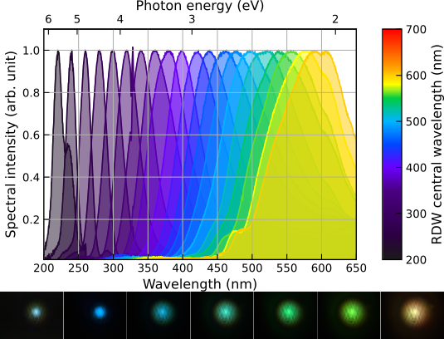

References
1. T Nagy et al., Appl. Opt. 47, 3264-3268 (2008).
2. A-L Viotti et al., Optica 9, 197–216 (2022).
3. Travers et al., Nat. Photonics 13, 547–554 (2019).
4. Lavenu et al., Opt. Express 27, 1958-1967 (2019)5. B. R. Jackson and T. Pitman, U.S. Patent No. 6,345,224 (8 July 2004).

