Shaping Light with Liquids: Attosecond Physics for Tunable EUV Sources
Dr. Angana Mondal
Advance Research Center for Nanolithography
Science Park 106, 1098 XG Amsterdam, The Netherlands
Van der Waals-Zeeman Institute, University of Amsterdam,
Science Park 904, 1098 XH Amsterdam, The Netherlands

ABSTRACT
High-harmonic generation (HHG) in bulk liquids is now understood through the scattering-limited three-step model [1]. In liquids, the harmonic cut-off stays nearly constant across laser parameters, a consequence of strong scattering and on-site recombination [1-2]. This raises a fundamental question: if liquids enforce a fixed cut-off, how is the excess energy redistributed as the driving intensity increases?
We report here the emergence of a second plateau in liquid-phase HHG spectra, indicating a new regime of electron dynamics driven by hole delocalization and recombination with neighboring molecules [3]. This plateau exhibits weak cut-off scaling and a characteristic ellipticity dependence, supported consistently by experiments, ab-initio simulations, and semi-classical modeling. Further, we use attosecond interferometry to reveal a strong linear atto-chirp and chemically tunable spectral minima [4-6], providing sub-femtosecond access to recollision pathways and the interplay of electrons, structure, and local fields. These findings deepen our understanding of ultrafast dynamics in condensed, disordered media. In addition, they point to a materials-driven strategy for designing tailored attosecond light sources, where solvation structure, chemical composition, and confinement can be engineered to enhance recollision channels and shape emission properties.

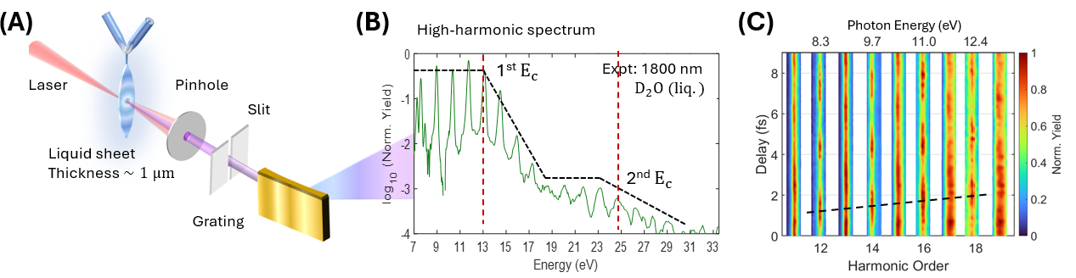
Figure 1. (A) Schematic of experimental set-up for generating HHG from bulk liquids (B) HHG spectrum from D₂O liquid at ~ 4.8 ×10¹³ W/cm² for 1800 nm wavelength. (C) Harmonic yield modulation in liquid ethanol with 1800/900-nm two-color laser pulses focused to a peak intensity of ~ 4 ×10¹³ W/cm²

References
1. A Mondal et al., Nature Physics 19, 1813 (2023)
2. A Mondal et al., Optics Express 31, 34348 (2023).M. P. Brown and K. Austin, Appl. Phys. Letters 85, 2503-2504 (2004).
3. A Mondal et al., Nature Photonics (2023)
4. N Dudovich et al., Nature Physics 2, 781 (2006).
5. G Vampa et al., Nature 522, 462 (2015).
6. A Mondal et al., arXiv:2509.12872v2 [physics.chem-ph] (2025).

