Comparison of STXM and SXP for the Morphological Study of Organic Semiconducting Nanoparticles Used for Hydrogen Production
Corentin Rieb^{a,b}, Nicolas Leclercª, Stéphane Méry^{c}, Thomas Cottineauª, Anne Hébraudª, and Sufal Swaraj^{b}*
ª Institut de Chimie et Procédés pour l’Energie, l’Environnement et la Santé (ICPEES), Université de Strasbourg - CNRS, UMR 7515, École Européenne de Chimie, Polymères et Matériaux (ECPM), 25 Rue Becquerel, Strasbourg 67087 CEDEX 02, France
^{b} Synchrotron SOLEIL, L’Orme des Merisiers, Départementale 128, Saint-Aubin, 91190, France
^{c} Université de Strasbourg, CNRS, IPCMS UMR 7504, 67034 Strasbourg, France

ABSTRACT
Organic Semiconducting (OSC) Nanoparticles composed of carefully selected mixtures of electron donor and acceptor materials were synthesized using mini-emulsion and nanoprecipitation techniques. These nanoparticles were employed in H₂ production through photocatalysis. It was found that the PTQ10/ITIC-4F pair without surfactant, in a morphology intermixed with Pt as a co-catalyst, has a 10 times higher hydrogen production rate than the core-shell morphology, but a reduced production stability over 24h (Figure 1C) [1].

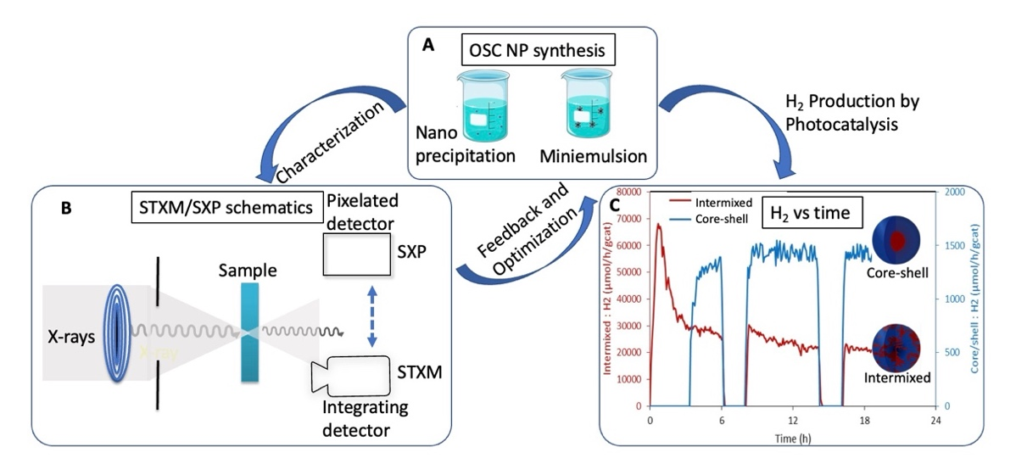
Figure 1: Overall schematics depicting (A) OSC synthesis (B) STXM/SXP schematics (C) H₂ production from photocatalysis vs time

In this presentation I will focus on the role STXM (Scanning Transmission X-ray Microscopy) and SXP (Soft X-ray Ptychography) has played in chemical and morphological characterization of these nanoparticles [2]. I will present practical aspects of these two techniques such as spatial resolution, radiation damage, and acquisition time along with some open questions.

References
1. Phd Thesis (Corentin RIEB, Univ. of Strasbourg, 16/12/2025).
2. Rieb, C., Leclerc, N., Méry, S., Hébraud, A., Swaraj, S. Journal of Physical Chemistry C., 129(41): 18537-18547. (2025).

