In situ Synchrotron Study of the 1T′/1H Phase Transition in Colloidal WS₂ Monolayers
Dario Mastrippolito^{a,b}, Erwan Bossavit^{a,b}, Mariarosa Cavalloª, Mathieu G. Silly^{b}, Francesco Capitani^{b}, Andrea Zitolo^{b}, José Avila^{b}, Francesco Carlà^{c}, Cesare Tresca^{e}, Emmanuel Lhuillierª, Benoit Mahler^{d}, Debora Pierucciª
a) Sorbonne Université, CNRS, Institut des NanoSciences de Paris, INSP, F-75005 Paris, France b) Synchrotron SOLEIL, L'Orme des Merisiers, Départementale 128, 91190 Saint-Aubin, France. c) Diamond Light Source Ltd, Harwell Science and Innovation Campus, Didcot, OX11 0DE UK. d) Universite Claude Bernard Lyon 1, Institut Lumiere Matière (iLM), UMR 5306, CNRS, 69622 Villeurbanne, France e) CNR-SPIN c/o Dipartimento di Scienze Fisiche e Chimiche, Università degli Studi dell’Aquila, L’Aquila, Italy
ABSTRACT
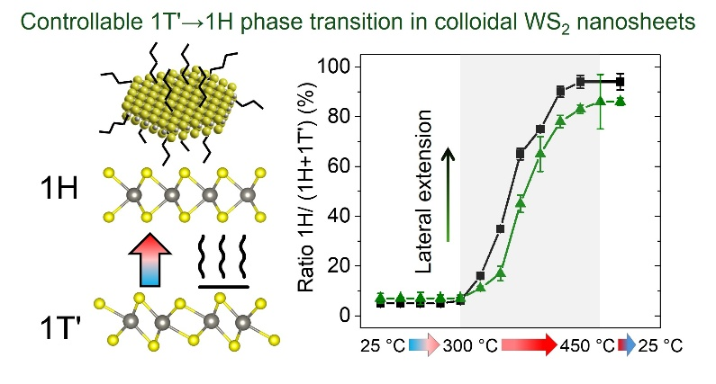
Controlling the crystalline phase of transition metal dichalcogenides (TMDs) is crucial for tailoring their electronic and optical properties. Among the polymorphs of WS₂, the metastable 1T′ phase exhibits a semimetallic or narrow-bandgap character distinct from the semiconducting 1H phase, making their interconversion a key challenge in phase engineering.^{1,2} Here, we employ a multi-technique synchrotron approach, combining in situ GIXD, XPS, and XAS measurements at the SOLEIL (TEMPO, SAMBA, ANTARES, SMIS) and DIAMOND (I07) facilities, to directly track both the structural and electronic evolution during the temperature-induced 1T′→1H phase transition in colloidally synthesized WS₂ monolayers stabilized with organic ligands.³ The reducing ligands used during synthesis stabilize the 1T′ phase through strong electron doping, ensuring phase stability up to ~300 °C. Upon annealing above this threshold, ligand decomposition triggers a reconstructive transformation toward the 1H phase. The results reveal a progressive disappearance of the 1T′ superstructure and the emergence of the prismatic 1H lattice, accompanied by distinct changes in the local W coordination. We find that the kinetics of this transformation are strongly influenced by the nanosheet's lateral size and surface chemistry, highlighting the interplay between doping, ligand decomposition, and lattice reorganization. These insights open new perspectives for controlled phase stabilization and scalable synthesis of polymorphic TMDs nanostructures.
Figure 1. Evolution scheme of the relative weight of the 1H phase with respect to the 1T′.

REFERENCES

1. Mahler et al., J. Am. Chem. Soc. 136, 40, 14121–14127 (2014)
2. Pierucci et al., Appl. Phys. Lett. 115, 032102 (2019)
3. Mastrippolito et al., Nanoscale, in press (2025)

