1s2p Resonant Inelastic X-ray scattering Natural Circular Dichroism
Alessandro De Frenza¹, James M. Ablett,¹, Nazanin Kordestani², Edwige Otero¹, Jean-Pascal Rueff^{1, 3}, Marie-Anne Arrio⁴, Amélie Juhin⁴, Patrick Rosa², Elen Duverger-Nédellec², Daniel Sier¹, Philippe Sainctavit^{1, 4} and Elizabeth A. Hillard²

¹ Synchrotron SOLEIL, L’Orme des Merisiers, Départementale 128, 91190, Saint-Aubin, France
² Univ. Bordeaux, CNRS, Bordeaux INP, ICMCB, UMR 5026, F-33600 Pessac, France
³ Laboratoire de Chimie Physique-Matière et Rayonnement, CNRS,
UMR 7614, Sorbonne Université, 4 Place Jussieu, 75252 Paris, France
⁴ CNRS, Sorbonne Univ, MNHN, IMPMC UMR 7590, F-75252 Paris, France

ABSTRACT
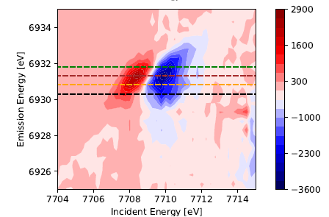X-ray natural circular dichroism (XNCD), that is the differential absorption with circularly polarized X-rays having opposite helicity by an optically active material, is a powerful characterization technique for probing local chiral and magneto-electric properties of a material. Resonant inelastic X-ray scattering (RIXS) is an element-selective and high-energy resolved spectroscopic technique implied to investigate electronic structure of molecules, similar to X-ray absorption (XAS). In this work, we employ 1s2p RIXS, which probes the Kα emission following the excitation of a 1s electron to empty 3d–4p orbitals in a transition metal. The compounds investigated are single crystals of metal-organic complexes of [Co(en)₃](No₃)₂ that crystallize in the P6₃22 space group. We previously measured a strong X-ray natural circular dichroic signal in these crystals [2] from measurements conducted at the GALAXIES RIXS end-station at SOLEIL [1]. High-Energy-Resolved Fluorescence-Detected X-ray Absorption (HERFD-XAS) spectra recorded with right- and left-circularly polarized light reveal a pronounced RIXS-NCD signal of about 23% relative to the pre-edge maximum. This represents a significant enhancement compared with previous XNCD measurements on the same compound, where the signal was approximately 9% [2]. RIXS-NCD also offers the possibility to measure full dichroic spectra for the emission. These spectra were recorded for the Δ- [Co(en)₃](No₃)₂ with the incident x-ray energy tuned close to the maximum of the RIXS-NCD signal at 7710 eV. The emission energy was scanned across the Co Kα₁ and Kα₂ lines for both helicities and for both axial and orthoaxial geometries. The observed dichroic signals follow the predicted angular dependence for XNCD in the P6₃22 symmetry [3]. As last result, a two-dimensional RIXS map combining both the 1s absorption and the 1s2p emission shows a clear dichroism over a wide energy range in the Co 1s pre-edge region.
RIXS-NCD map at Co K-edge in Δ- [Co(en)₃](NO₃)₂

References

- J. Ablett, D. et al, J. Synchrotron Rad. 26 (1), 263 (2019).
- M. Cortijo, et al., Crystals 10 (6), 472 (2020).
- C. Natoli, C. Brouder, P. Sainctavit, J. Goulon, Eur. Phys. J. B 4 (1), (1998).

