Radiation Damage with Soft X-rays in Organic and Hybrid Semiconducting Materials
Sufal Swaraj
Synchrotron SOLEIL, L’Orme des Merisiers, Départementale 128, Saint-Aubin, 91190, France

ABSTRACT
Radiation damage during soft X-ray characterization poses a challenge in the study of organic and hybrid electronic materials, especially in energy devices. Understanding dose limits and the nature of chemical degradation is essential for reliable interpretation. We focus on materials like PMMA (control), fullerene derivatives (PCBM, PC₇₁BM), and donor polymers (e.g., PTB7-Th, PDTS), which are commonly studied in the X-ray energy range of 280–320 eV [1, 2]. X-ray induced radiation damage in these key organic and hybrid photovoltaic materials is systematically investigated in this study. Using varied exposure times and exposure energies, we quantify spectral changes and damage thresholds in these materials. X-ray induced damage in hybrid metal halide perovskite solar cell materials is also presented.

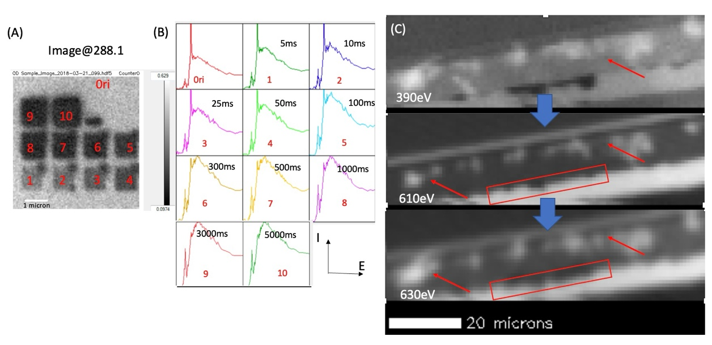

Figure 1. (A) STXM images at 288.1eV of PMMA thin film showing regions damaged at different exposure times. (B) C K-edge spectral changes corresponding to the different regions in (A). (C) STXM images of MAPI (CH₃NH₃PbI₂) perovskite layer showing evolution/damage of certain regions (red arrows and rectangles)

References
1. Hitchcock, A. P. (2012). Soft X-ray spectromicroscopy: Techniques and applications. Journal of Electron Spectroscopy and Related Phenomena, 185(3-4), 1–19.
2. Wang, J., & Morin, C. (2009). Radiation damage during soft X-ray spectromicroscopy of polymers. Journal of Electron Spectroscopy and Related Phenomena, 173(1-3), 20–26

