Entropy-Induced Assemblies of Plasmonic Nanoparticles
Jaime Gabriel Trazo,ª Claire Hotton,ª Nika Kutalia,ª Jules Marcone,ª Claire Goldmann,ª Damien Alloyeau,^{b} Erwan Paineau,ª Doru Constantin,^{c} Patrick Davidson,ª Thomas Bizien,^{d} Marianne Impéror-Clerc,ª Cyrille Hamonª
a Université Paris-Saclay, CNRS, Laboratoire de Physique des Solides Orsay 91405, France
b Université Paris-Cité, Laboratoire Matériaux et Phénomènes Quantiques Paris 75013, France
c Institut Charles Sadron, CNRS and Université de Strasbourg, 67034 Strasbourg, France
d SWING Beamline, SOLEIL Synchrotron, 91190 Gif-sur-Yvette, France

ABSTRACT

Our research focuses on metamaterials, assemblies of nanoparticles (NPs) capable of controlling light. Traditionally static, these systems remain limited in their applications. Our goal is to develop dynamic metamaterials by tuning the entropy of the system. Our approach consists in exploiting depletion induced self-assembly (DISA) of NPs to form reconfigurable materials by in situ tuning depletion forces. Colloidal materials displaying hierarchical chirality,¹ controlled dimensionality² and shape alloys³ have been prepared by DISA. In all case, we used Small Angle X-ray Scattering (SAXS) to resolve the structure at ensemble level and in some case we complemented the characterization by in situ electronic microscopy. Results acquired on the SWING beamline will be showed, including recent DISA kinetics taken in levitated droplets.
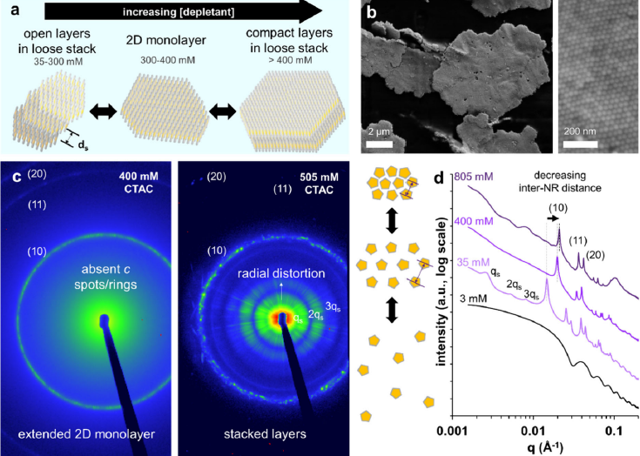
Figure: example of nanorods assemblies using DISA and two selected 2D SAXS images showing the formation of colloidal raft. Taken from Ref²

References

1. Trazo, J. G.; Serrano Freijeiro, A.; Mychinko, M.; Kutalia, N.; Imperor-Clerc, M.; Bals, S.; Liz-Marzan, L. M.; Perez-Juste, J.; Pastoriza-Santos, I.; Hamon, C. Tunable Plasmonic Circular Dichroism of Hierarchical Chiral Assemblies. Chem Mater 2025, 37 (16), 6237-6245.
2. Trazo, J. G.; Marcone, J.; Nag, R.; Goldmann, C.; Kutalia, N.; Bizien, T.; Pansu, B.; Impéror-Clerc, M.; Hamon, C. Colloidal Tunable Metasurfaces via Depletion-Induced Self-Assembly of Plasmonic Nanorods. ACS Applied Materials & Interfaces 2025.
3. Nag, R.; Rouviere, N.; Trazo, J. G.; Marcone, J.; Kutalia, N.; Goldmann, C.; Imperor-Clerc, M.; Alloyeau, D.; Constantin, D.; Hamon, C. Depletion-Induced Tunable Assembly of Complementary Platonic Solids. Nano Lett 2024, 24 (51), 16368-16373.

