Harnessing X-rays to Reveal Historical Productions in Late Iron Age Britain
Courtney Nimura¹, Mary Davis², Susan Nehzati³
¹ Ashmolean Museum of Art and Archaeology, University of Oxford, Beaumont St, Oxford OX1 2PH
² National Museum of Scotland, Chambers St, Edinburgh, Scotland, EH1 1JF
³ Diamond Light Source, Diamond House, Harwell Science and Innovation Campus, Fermi Ave, Didcot, England, OX11 0DE

ABSTRACT
Heritage materials provide valuable records of past human activity and researching them helps illuminate key transitions in historical cultural development. A decorated Iron Age terret currently displayed in the European Prehistory Gallery of the Ashmolean Museum, Oxford, provides a unique opportunity to investigate glass production and exchange in late Iron Age Britain. Found in Suffolk, England, and dated 50 BCE–75 CE, this copper-alloy terret is ornamented in the characteristic La Tène style, featuring incised embellishments and coloured glass inlays. The red glass is identified as the distinctive “sealing wax” red [1] commonly found in prestigious metal artefacts of this period, yet the origin and significance of the dark, translucent blue glass is less well understood.

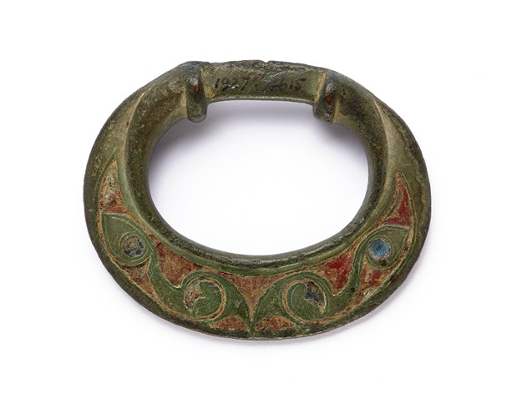
Late pre-Roman Iron Age terret used in analysis.

Using X-ray fluorescence imaging (XRF) and X-ray absorption near-edge structure (XANES) at Diamond Light Source, we examined the chemical composition and production technology of the glass inlays. We characterised the chemical composition of the terret glass, compared with Corning glass reference standards [2], particularly focusing on iron, copper, and lead.

The results provide new evidence for the production, use, and circulation of coloured glass in pre-Roman Britain, enabling a more detailed reconstruction of the object’s biography. More broadly, the study contributes to our understanding of craft practices, material exchange, and social networks in late Iron Age Britain.

References
1. M. Davis. (2017) “’Sealing wax’ red glass in Late Iron Age Britain”, PAST The Prehistoric Society Newsletter, 86, pp.5-7.
2. E.P. Vicenzi, S. Eggins, A. Logan, and R. Wysoczanski. J. Res. Natl. Inst. Stand. Technol. 107, 719-727 (2002).

