Combined XAFS/DRIFTS/MS : a powerful technique for operando catalysts investigations
D. Salusso, K. A. Lomachenko and O. Mathon
European Synchrotron Radiation Facility, Grenoble, France

Diffuse Reflectance Infrared Fourier Transformed (DRIFTS) and X-ray Absorption (XAS) spectroscopies are two of the most employed techniques for catalyst characterization under reaction conditions. However, comparison of kinetics from the two experiments is not trivial due to the differences of the setups. In this talk the key advantages of measuring simultaneous XAS and IR spectra within the same reactor will be presented.
The set-up developed at BM23 and ID24-DCM ESRF beamlines combines a commercial infrared (IR) spectrometer where custom Au-mirrors guide the light on an in-house developed reactor cell allowing to simultaneously collect DRIFTS and XAS either in transmission or in fluorescence modes. The latter is of paramount importance since current catalytic research favors lower metal loadings that maximize atom efficiency. Moreover, the reactive gases pass through the sample reproducing a tubular reactor while products are collected and identified by an online Mass Spectrometer (MS).
In the panorama of catalytic reactions, simultaneous measurement of DRIFTS/XAS/MS allows to identify the catalysts surface and bulk species associated to the catalytic activity. In this presentation the set-up capacities will be presented through the study of NiCeO₂ catalysts under Sabatier reaction (CO₂ + 4H₂ CH₄ + 2H₂O, 300⁰C) where the results provided a clear correlation between NiO/Ni -Ce⁴⁺/Ce³⁺ redox properties, surface carbonates coordination and methane production. [1,2]
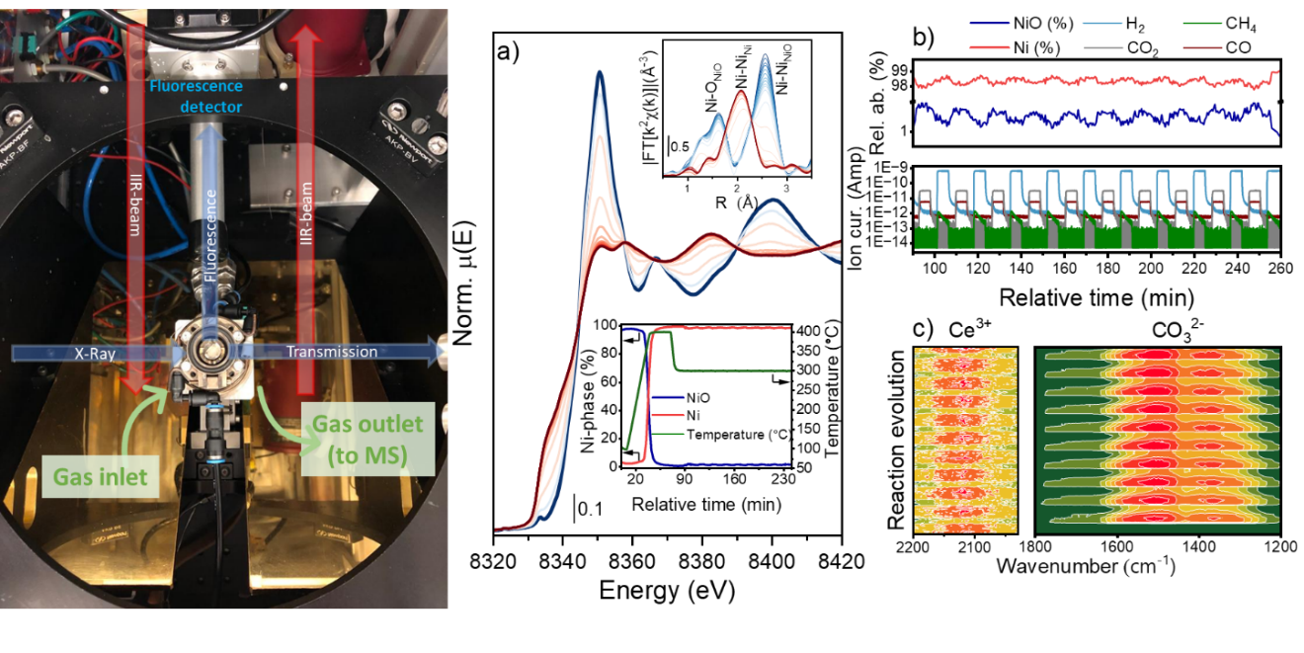
Figure. (left) DRIFTS/XAS reactor. Operando a) Ni K-edge XANES and (top inset) FT-EXAFS spectra with (low inset) MS results. Temperature increases from blue to red line. b) Detail of (top) NiO/Ni modulation with (low) MS data. c) Ce³⁺ and CO₃²⁻ DRIFTS maps measured during CO₂/H₂ modulation.

[1] Salusso D. et al., under submission, ACS Catalysis.
[2] Data collected on ID24-DCM (ESRF), beamtime CH-7064 [doi.org/10.15151/ESRF-ES-1647799173]

