From Monometallic to Bimetallic NiCo/SiO₂: Element-Resolved Active-Site Identification by Operando XAS and MCR-ALS
Shuchi Zhang, Nikolay Kosinov*
Department of Chemical Engineering and Chemistry, Eindhoven University of Technology, The Netherlands
s.zhang7@tue.nl; n.a.kosinov@tue.nl

ABSTRACT
Operando X-ray absorption spectroscopy (XAS) is a powerful technique for probing the electronic and local structural evolution of catalysts under working conditions. However, the obtained spectra often contain mixed structural information under reaction conditions. Multivariate Curve Resolution–Alternating Least Squares (MCR-ALS) is an effective method for analyzing linearly mixed datasets and can decompose them into independent components, which can help a lot in XAS data analysis¹.
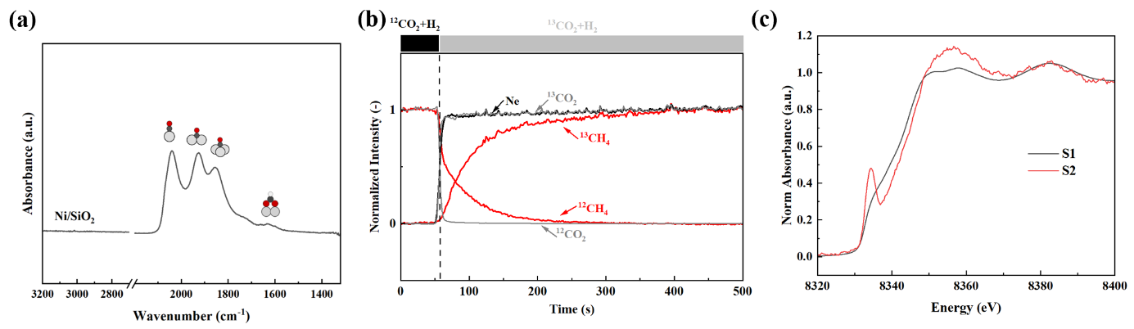
Our previous work on Ni/SiO₂-catalyzed CO₂ methanation revealed CO* as the dominant surface species, while operando XAS gas-switching experiments showed a corresponding change in the Ni spectral features². Recently, at ROCK beamline (SOLEIL), we performed meticulous transient gas switching experiments (H2↔CO2+H2) followed by XAS over Me/SiO2 (Me= Ni or Co) and NiCo/SiO2. We applied MCR-ALS analysis to operando XAS datasets to further identify the intermediates dynamic changes on the surface. We confirmed the intermediates mainly composed by CO* by FTIR (Figure.1a). CO* coverage was calculated using chemisorption and Steady-state isotopic transient analysis (SSITKA) (Figure.1b), also performs as the reference value of MCR-ALS analysis, which gives us the XAS spectra of both metal (S1) and CO-adsorbed metal (S2) (Figure.1c). Substituting these two standard spectra as reference components for the NiCo/SiO2 sample in MCR-ALS, we obtained the CO coverage on the Ni and Co, respectively, as 6.7% (Ni bases) and 2.0% (Co bases), which highly indicated the activity of both metals. This provides an effective element-resolved method for identifying active sites and their activities on alloy catalysts.
Figure1. (a) FTIR spectra of Ni/SiO₂ during CO₂ hydrogenation at 220 ºC. (b) SSITKA results during ¹²CO₂+H₂ switch to ¹³CO₂+H₂ during steady state CO₂ hydrogenation at 220 ºC. (c) Pure spectra obtained by MCR-ALS using 4.2% CO* adsorbed Ni as S2.

References
1. S. R. Docherty, O. Safonova and C. Coperet, J. Am. Chem. Soc, 2023, 145, 13526-13530.
2. J. F. M. Simons, T. J. de Heer, V. Muravev, N. Kosinov and E. J. M. Hensen, J. Am. Chem. Soc. 145 (2023) 20289.

