Developments of the setup for pump-probe X-ray absorption fine structure (XAFS) and a capability of EXAFS at FXE instrument, European XFEL
Y. Uemura, P. Zalden, X. Huang, F. Ardana-Lamas, M. Biednov, F. A. Lima, H. Wang, D. Khakhulin, H. Xu, P. Frankenberger, M. Knoll, S. Huynh, C. Milne*
FXE Instrument, European X-ray Free Electron Laser Facility GmbH

ABSTRACT
X-ray Absorption Fine Structure (XAFS) is one of the most essential techniques for materials characterisation. XAFS is applied to various systems, such as solid-state materials or molecules in solution in synchrotrons. Besides, XAFS has been employed to study photoexcited states of materials on ultrafast timescales since the X-ray Free Electron Lasers (XFELs) began operating. The Femtosecond X-ray Experiments (FXE) instrument at the European X-ray Free Electron Laser (EuXFEL) is dedicated to the study of photoexcited states of materials using a pump-probe methodology. At FXE, non-resonant X-ray Emission Spectroscopy (nr-XES) has been regularly employed to track photoexcited states of molecules in solution, taking advantage of the full XFEL flux since nr-XES requires neither monochromatic x-rays nor energy scanning. Resonant X-ray spectroscopies such as XAFS, which require monochromatic X-rays at XFELs, have been more challenging because of the intrinsically stochastic X-ray spectral features of the self-amplified spontaneous emission (SASE) process.
At FXE, we have recently been focusing on developing XAFS measurements. The unique operation mode at EuXFEL, i.e. burst operation, allows us to use more X-ray photons compared to other XFEL facilities, which should translate into XAFS spectra with a good signal-to-noise (S/N) ratio and shorter acquisition times. In addition, the XAFS capability is important for our user community since XAFS is a standard measurement for materials science, and advanced X-ray spectroscopic measurements, such as high-energy-resolution fluorescence-detected x-ray absorption spectroscopy (HERFD-XAS), also become possible if XAFS measurements at FXE is established to a sufficiently high level.
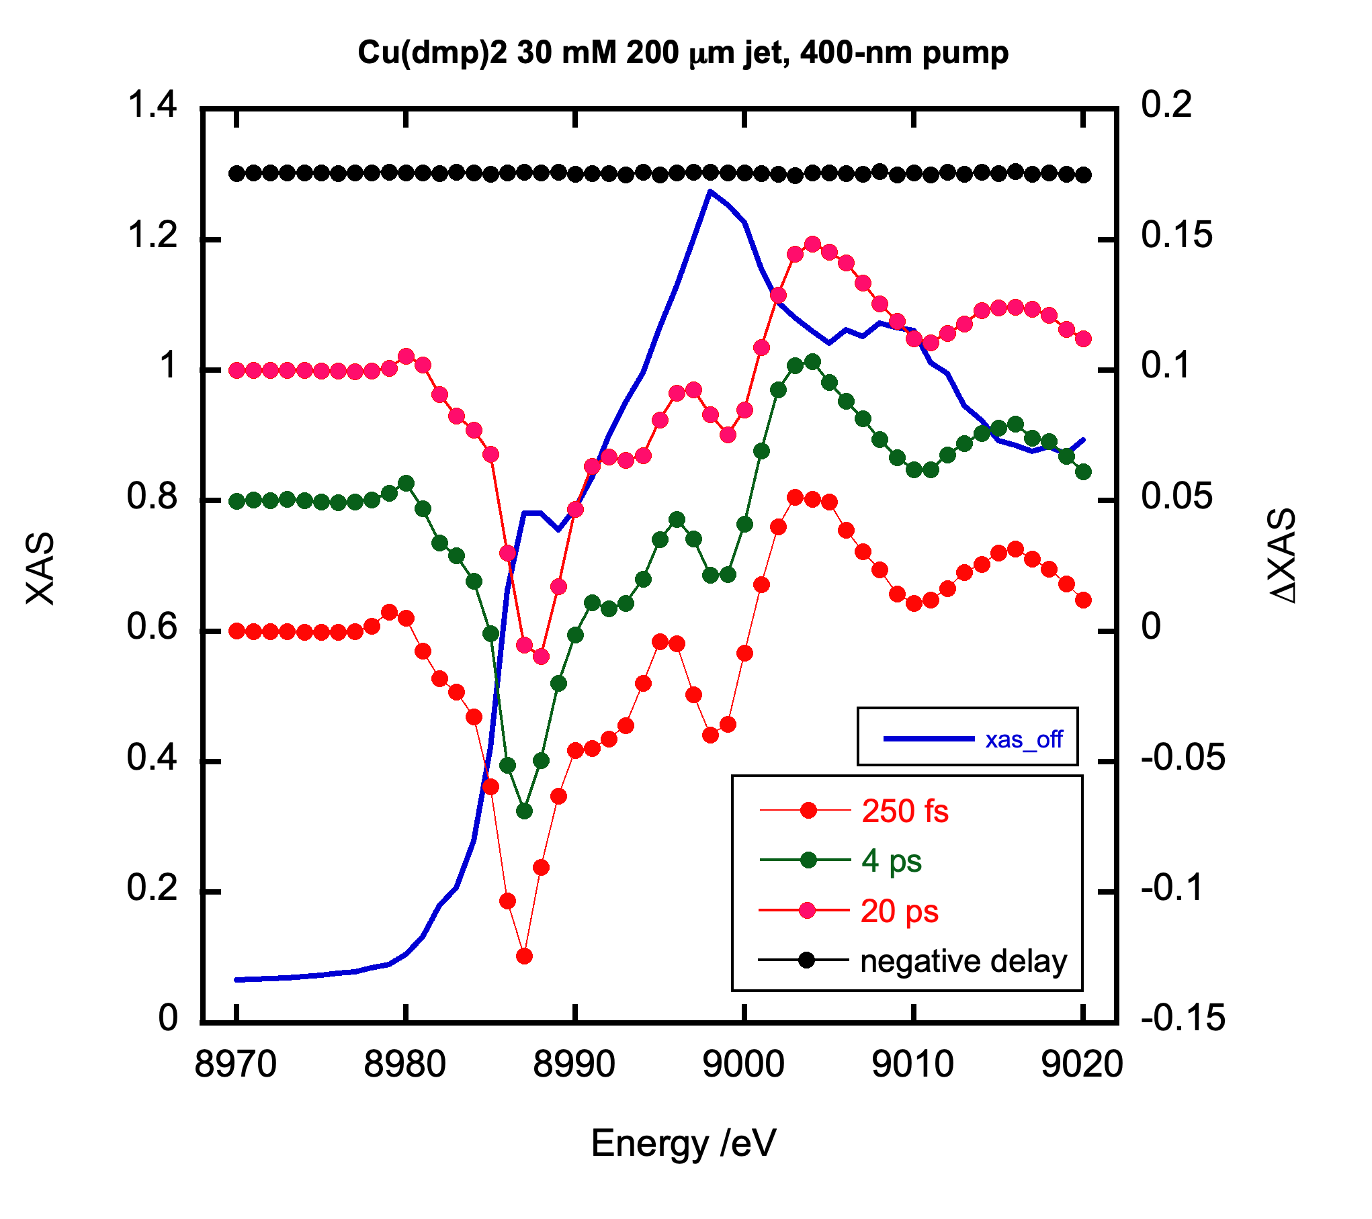
In Fig. 1, pump-probe XAFS of Cu(dmp)₂ molecules measured at FXE is displayed. The X-rays are monochromatized using a set of Si (111) crystals, and the incident and fluorescence X-ray intensities are measured using PIN photodiodes. 1000 pulses/s were used to measure XAFS and each data point was accumulated for 10 s (~10 min/spectrum). The signal-to-noise ratio (S/N) of pump-probe XAS (i.e. ΔXAS_{positive_delay}/ ΔXAS_{negative_delay}) is estimated to be ~100. More X-ray pulses at EuXFEL enabled a good S/N for the 10-s data acquisition. 10000 pulses are available at EuXFEL for 10 s while 300 – 1000 pulses are available for 10 s in other facilities. The S/N of XAFS at EuXFEL can be 3 times better than in other facilities. In addition to many X-ray pulses, a shorter burst period can reduce noise from jet fluctuations, which are more pronounced at longer pulse periods. Owing to the establishment of the XAFS setup, resonant XES is also available in combination with the setup of nr-XES. Furthermore, EXAFS can be measured by scanning the monochromator and the undulator together. In this presentation, we will discuss our recent achievements in XAFS.
Fig. 1 pump-probe XAFS of Cu(dmp)₂ molecules using a liquid jet (diameter: 200 µm)

