ROCK: a versatile beamline for operando quick-XAS monitoring at the second and micrometer resolution.
Laurent Barthe¹, Anthony Beauvois¹, Stéphanie Belin¹, Valérie Briois¹.
¹ Synchrotron SOLEIL, L’Orme des Merisiers, Saint Aubin BP 48, 91190 Saint Aubin, France
ABSTRACT
ROCK (Rocking optics for Chemical Kinetics) is the quick X-ray Absorption Spectroscopy beamline at SOLEIL¹ whose main applications are the in situ/operando XAS characterization of energy-related materials². ROCK is equipped with 3 cam-driven channel-cut monochromators working between 4 and 40 keV³ (Fig. 1a) with oscillation velocity ranged from 0.1 to 20 Hz for sub-second time resolution acquisition. A large portfolio of setups for monitoring the dynamic evolution of batteries (Fig. 1b) and catalysts (Fig. 1c to f) in working conditions is proposed to the users. The beamline is fully optimized to probe several elements on a single experiment by alternate XAS acquisition between several edges using the so-called edge jumping operation mode (Fig. 1g). Full Field (FF) XAS hyperspectral imaging (Fig. 1h) using a pixelated CMOS camera allows to reach a micrometer spatial resolution in addition to the second time resolution⁴. ROCK has gained a sound background in using chemometrics tools such as Multivariate Curve Regression with Alternating Least Square (MCR-ALS)⁵ fitting allowing to isolate from huge Quick-EXAFS dataset the species involved in the reaction and their concentration profiles. To overcome bulk sensitivity of XAS making difficult to differentiate the spectator species from the active species, modulation-excitation XAS (MEXAS) with phase sensitive detection (PSD) has been recently implemented to highlight the contribution of active species during a chemical process⁶ (Fig. 1i).
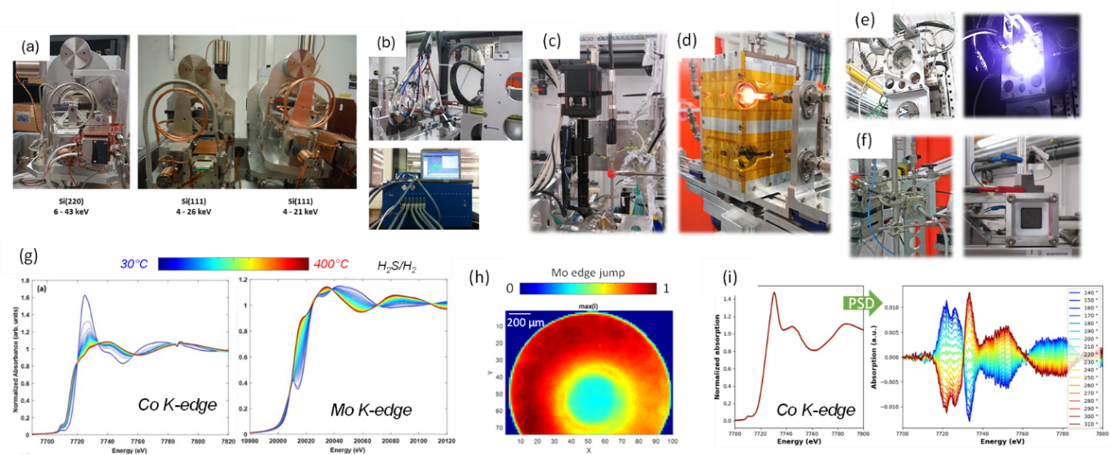
REFERENCES
1. V. Briois et al. J. Physics Conferences Series, 712: art.n° 012149 (2016)
2. C. La Fontaine et al., Synchrotron Radiation News, 33 20 (2020)
3. E. Fonda et al. J. Synchrotron Radiation 19 417 (2012)
4. V. Briois et al. J. Synchrotron Radiation 31 1084 (2024)
5. W. Cassinelli et al. Catalysis Today, 229,114, (2014)
6. H. Farhat et al., J. Phys. Chem. C, 128, 21023, (2024)

