Quantifying Electronic Energetics And Surface Properties Of Aqueous Solutions
Stephan Thürmer
Department of Chemistry, Graduate School of Science, Kyoto University, Kyoto, 606-8501 Japan

ABSTRACT
Liquid-jet photoelectron spectroscopy (LJ-PES) gives direct access to the electronic structure of aqueous solutions, information on bonding interactions, solute charge states and charge transfers via measurement of binding energies (BEs) of both solvent and solute. Yet, obtaining accurate BEs has been notoriously difficult due to the presence of undesired extrinsic liquid-jet potentials, such as the streaming potential, Φ_{str},¹ which lead to arbitrary energy shifts in PES. Interfacial properties are, in principle, inferable from work-function, WF, measurements. However, WF values from solution can only be obtained indirectly via energetic reference to a metal; such referencing is also compromised by arbitrary energy shifts of the liquid spectra.
We developed robust vacuum referencing as well as equilibrated Fermi-level referencing methods for BEs, which enable us to discern changes as a function of concentration in the solvents electronic structure as well as in WF, due to surface-dipole effects.²⁻⁴ A breakthrough for applicability of Fermi-referencing to arbitrary solutions is the quantification of all potentials in a LJ-PES experiment, most prominently Φ_{str}. We succeeded in quantifying Φ_{str} as a function of solute type and concentration, which enabled us to determine BE and WF values from model electrolyte solutions over a wide range of concentrations for the first time.⁵
These techniques mark a major advance in our ability to quantify electronic-structure interactions and chemical reactivity, which now extends to the measurement of absolute-scale bulk and interfacial solution energetics, including those of relevance to aqueous electro-chemical processes. Furthermore, quantification of the streaming potential promises to reveal insights about the solution-nozzle interfacial structure. I will discuss details of this technique, present results of exemplary solutions, and give an outlook on future developments.
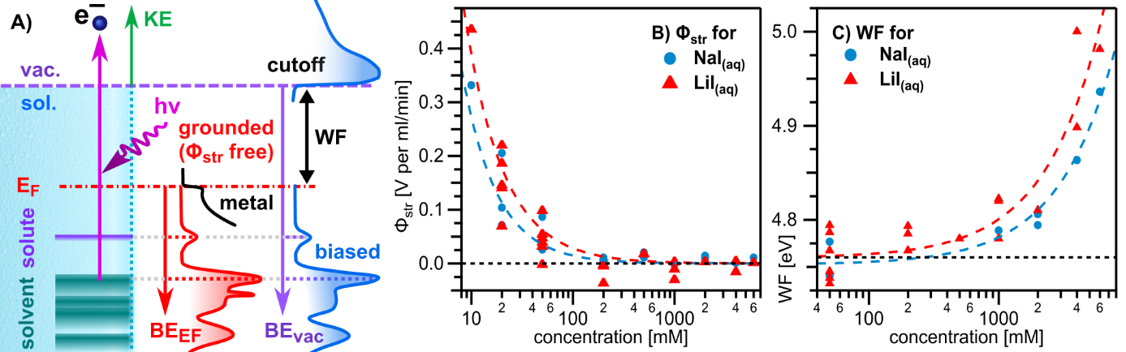
Figure: A) Overview of relevant energetics. B) Φ_{str} and C) WF values from solution.

References
1. M. Faubel, B. Steiner and J. P. Toennies, The Journal of Chemical Physics 106, 9013-9031 (1997).
2. S. Thürmer et al., Chemical Science 12, 10558-10582 (2021).
3. B. Credidio et al., Physical Chemistry Chemical Physics 24, 1310-1325 (2022).
4. M. Pugini et al., Chemical Science 14, 9574-9588 (2023).
5. H. Kaur et al., in preparation

